**Vtiger CRM**

Creating Leads

Index of leads, here we can add new leads using AddLeads button and also we can filter all the created leads with respect to its table header. We can see detail by clicking into the corresponding lead rows(in table),then it will navigate to the detail page

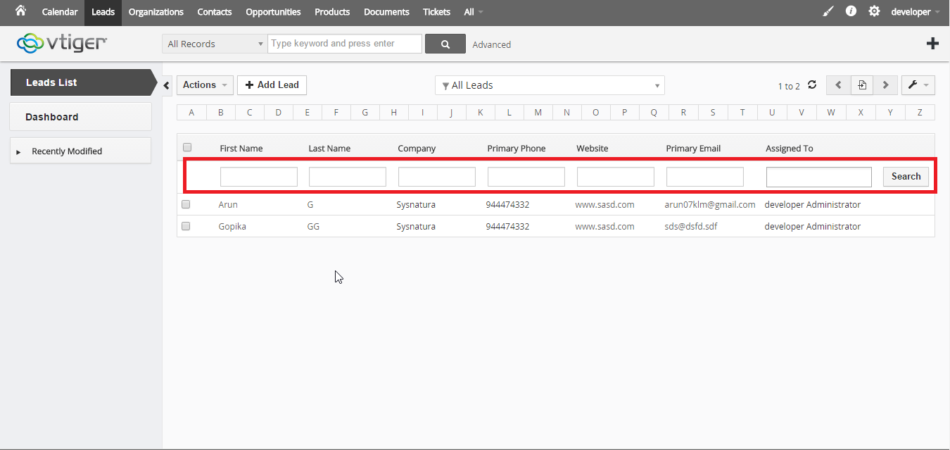

Create New Lead

Here we can create new leads in this case only ‘last name’ and ‘assigned to’ are mandatory.

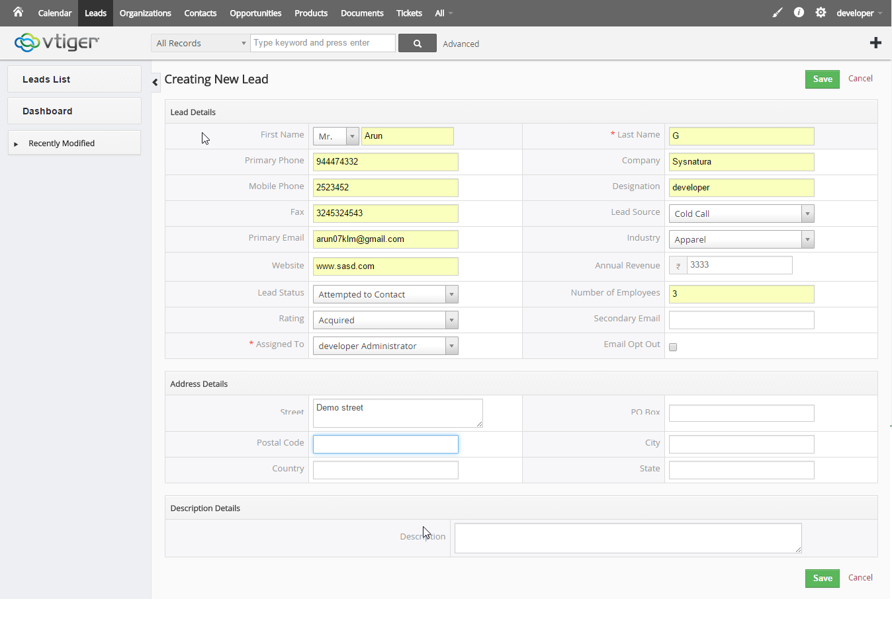

**Lead Details**

**In detail page there we can see a tab named Lead summary each link inside that tab will shows the detail view of each events related to that lead, like Activities, Updates, Comments etc. And here we can edit each field by double clicking is an added advantage**

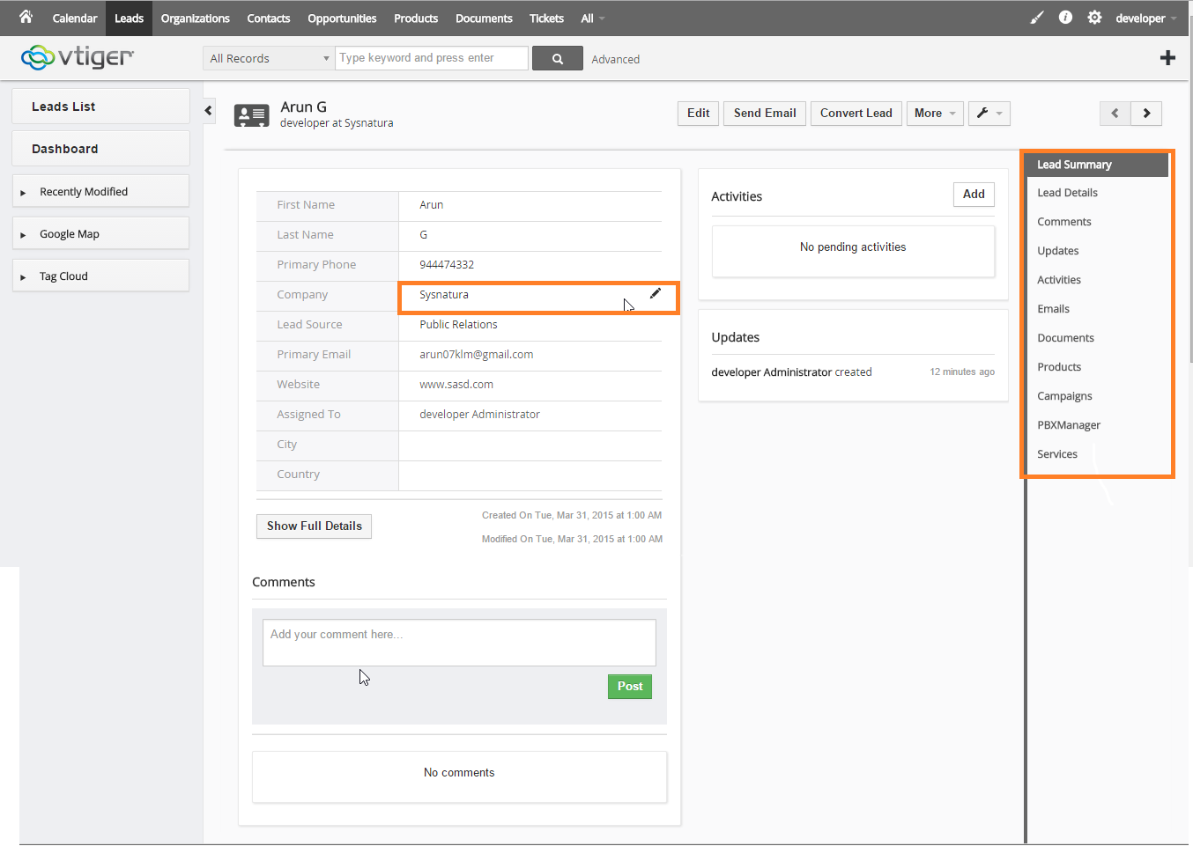

**Quick Master Creating Bar**

**There we can see a plus button and it contain all masters link when we clicked a master link then that master will open in a new popup and also we can create new master .**

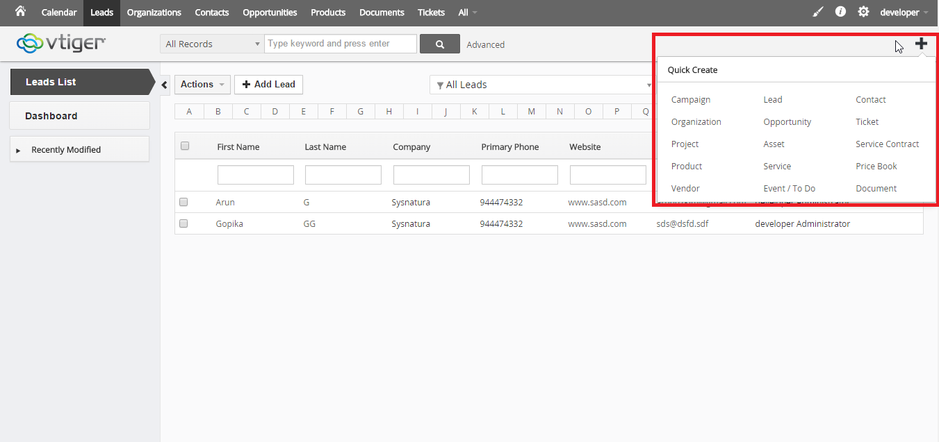

**Convert lead**

We can convert lead to organization or contact or opertunity

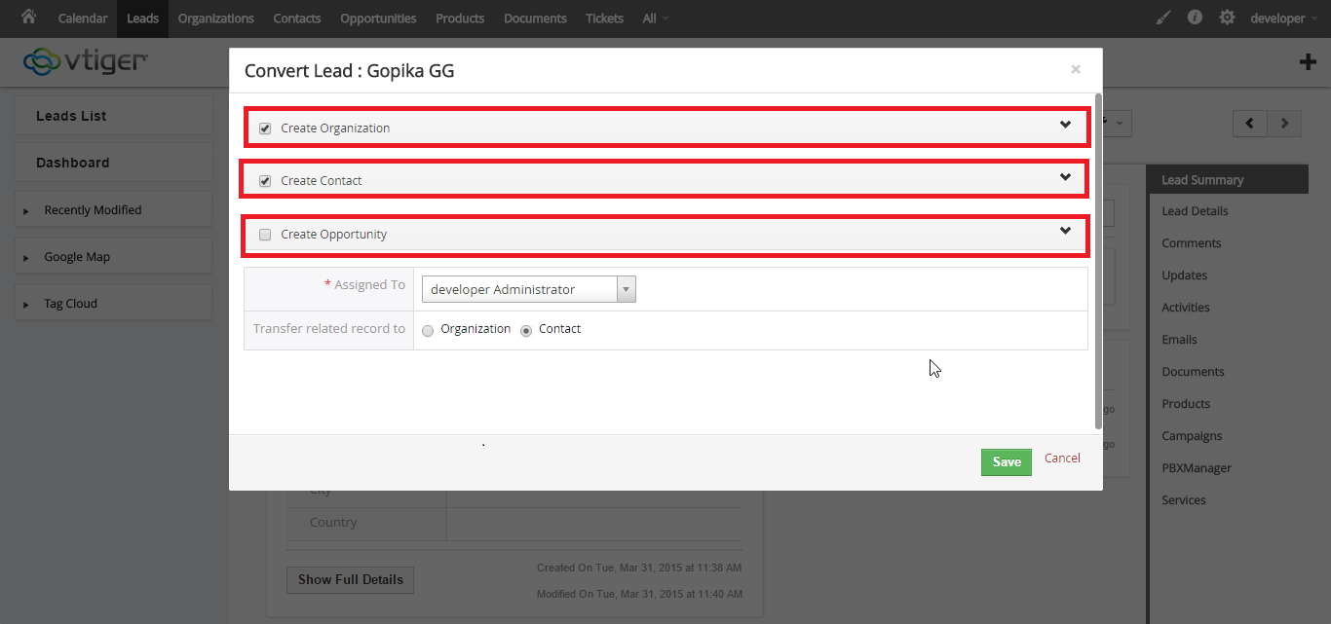

**Organization index**

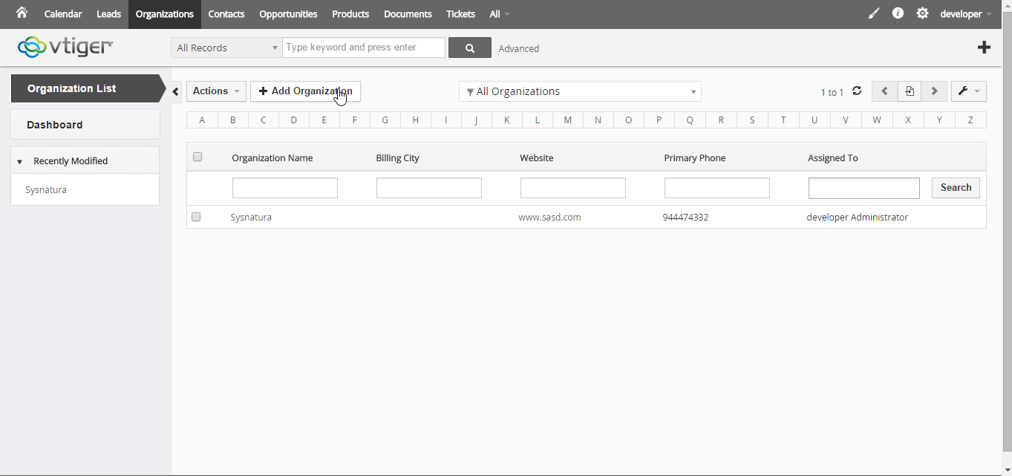

**Create New Organization**

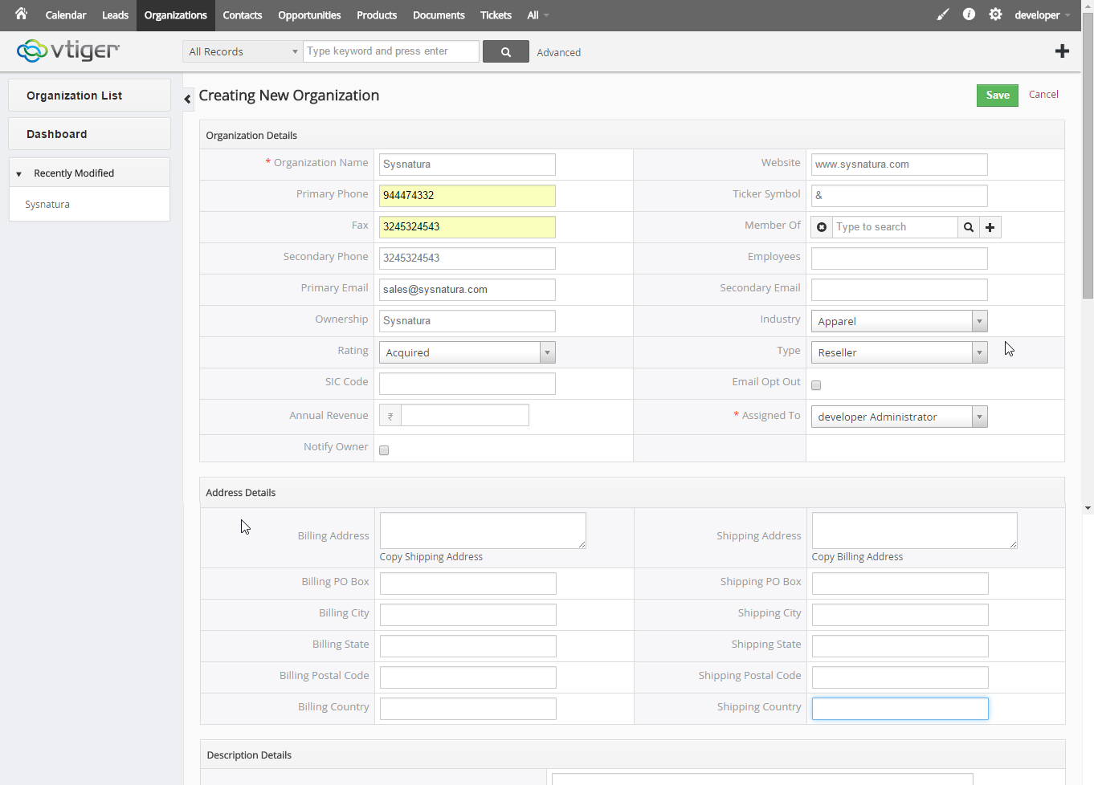

**Contacts Index**

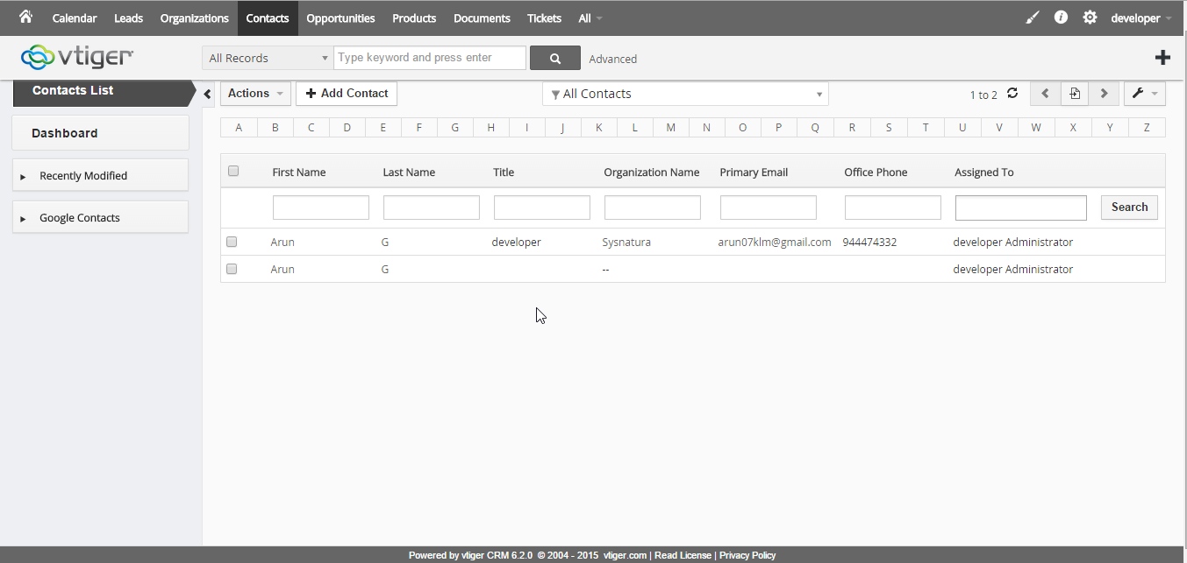

**Create new contacts**

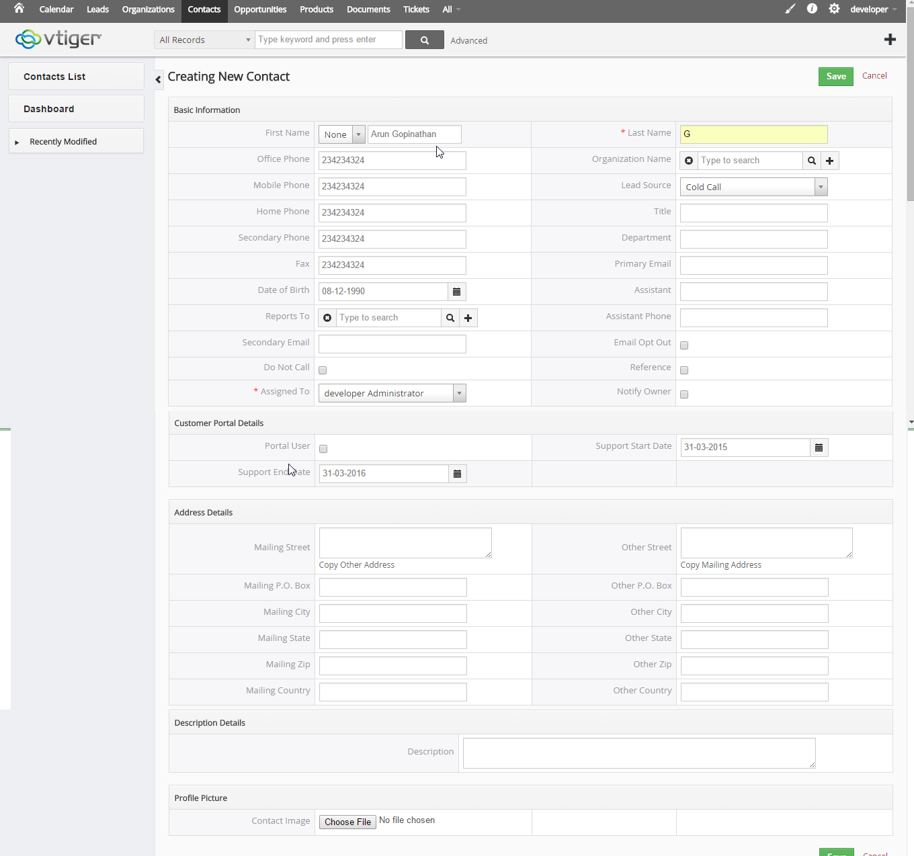

**Opportunity Index**

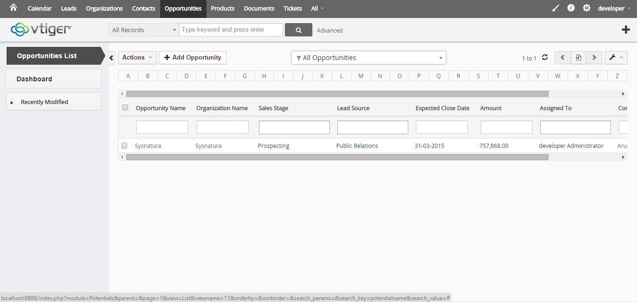

**Opportunity Edit**

Here we can add activities using Add buttons

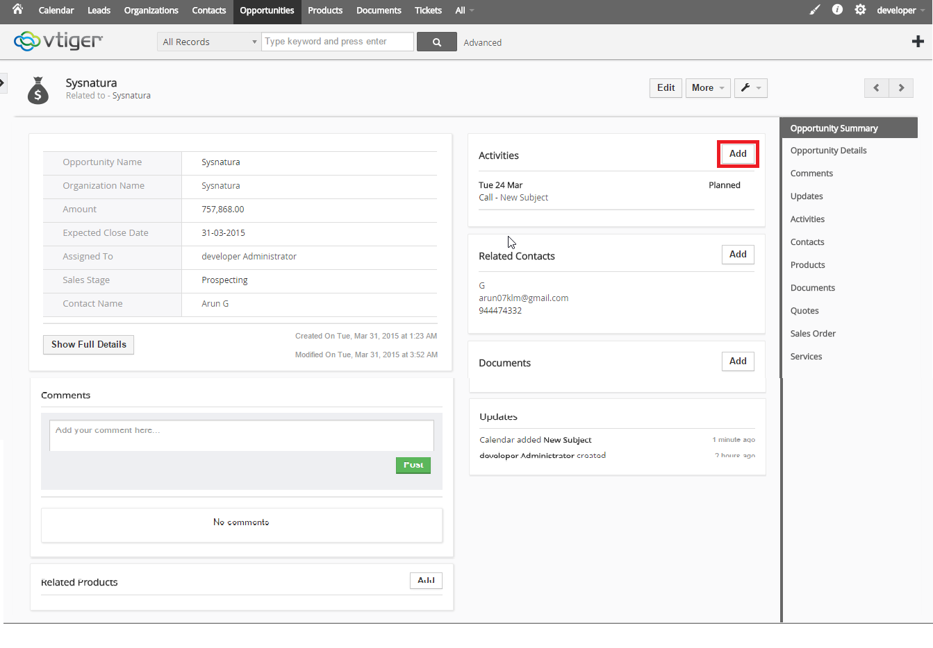

**Add activities**

Add activities like events or todo ,we got alerts with respect to the time scheduled.

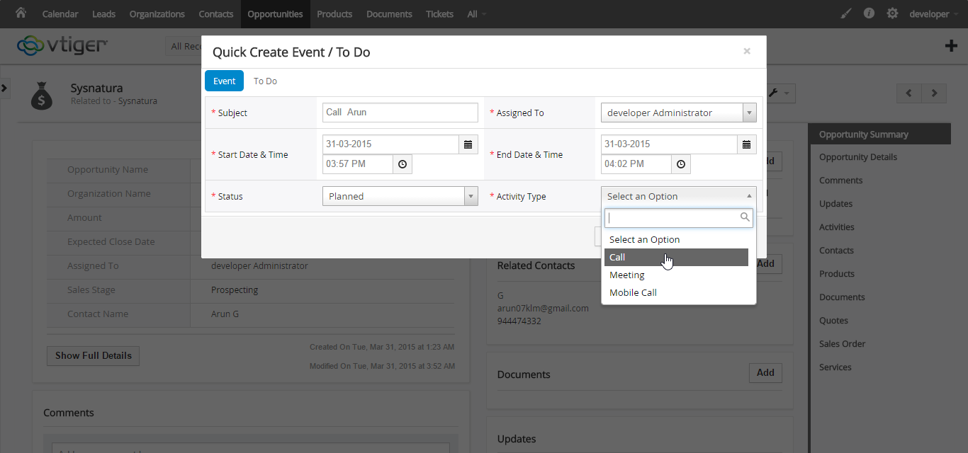

**Tickets**

Add customer complaints .each plus button will open corresponding pages such as organization list contact list or product name list in a new window. I think it will helps reduce client side load

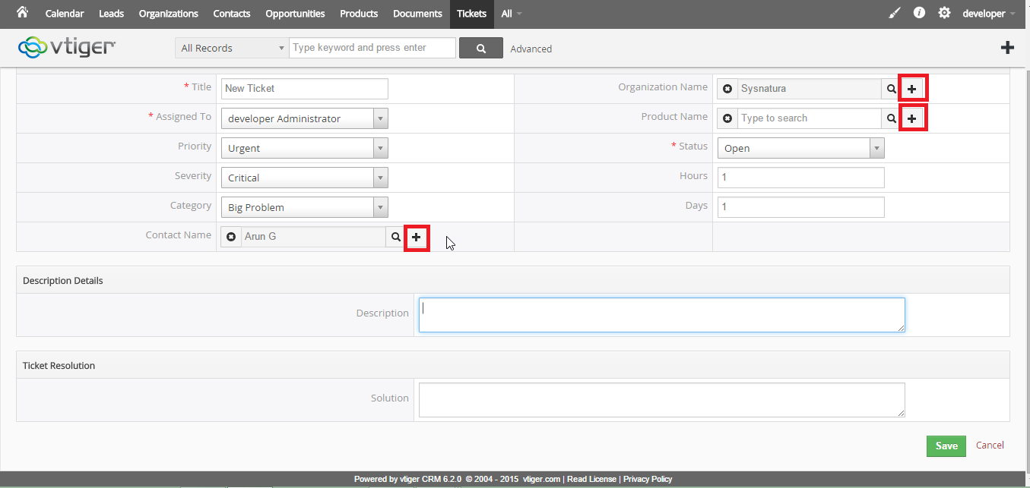

**Ticket Detail**

This page contain all details about the customer complaints and also there we can noticed comments of customer and post it. It will helps to identify the feedback of customer while calling next time.

